Constructing Hyperbola

Definition
# Source: AI Source: Provided by: [Data Path: Persons Table -> ID Column: 1, Name_En Column: Motasem Essam] -> From: [ChatGPT] on [7/25/2026]
A hyperbola is a conic section consisting of two separate, open branches.
It can be defined as the set of all points $P$for which the absolute difference between the distances to two fixed points, called the foci, is constant.
If the foci are $F_{1}$and $F_{2}$, then:
$$\boxed{∣PF_{1}-PF_{2}∣=2a}$$
where $2a$is the length of the transverse axis.
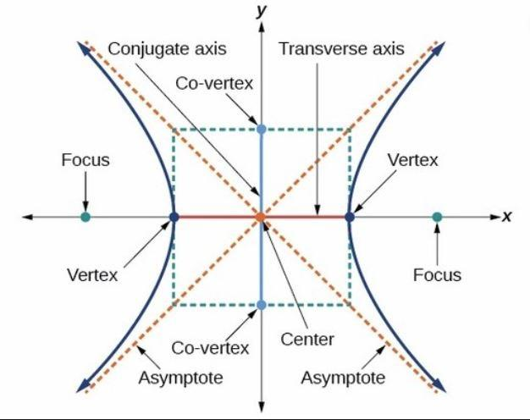
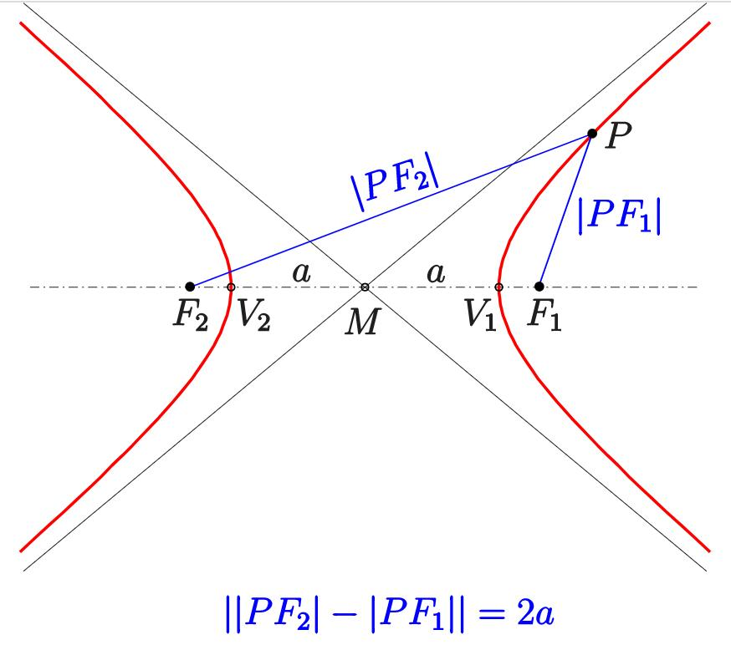
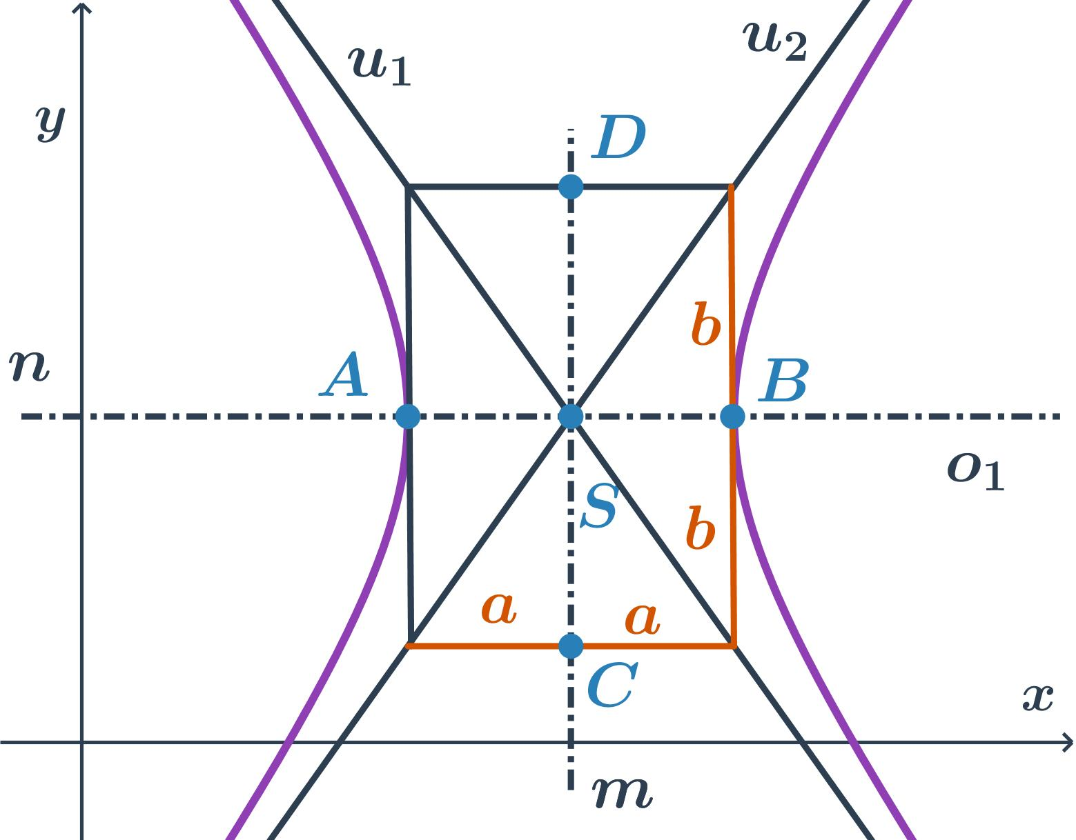
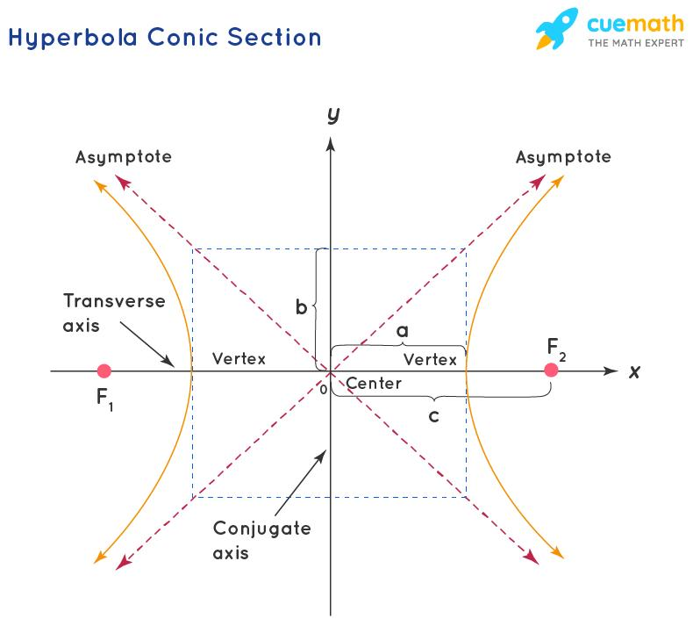
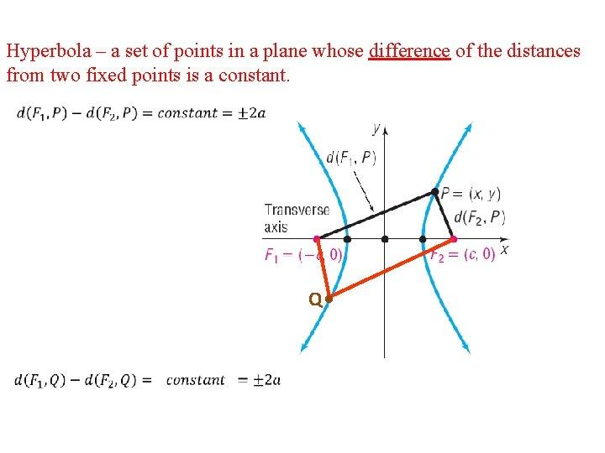

Fundamental Elements of a Hyperbola
# Source: AI Source: Provided by: [Data Path: Persons Table -> ID Column: 1, Name_En Column: Motasem Essam] -> From: [ChatGPT] on [7/25/2026]
Center
The midpoint between the two foci is the center $O$.
Foci
The two fixed points are:
$$F_{1}, F_{2}$$
Their distance from the center is:
$$\boxed{c}$$
Vertices
The two principal vertices are:
$$A, A^{'}$$
The distance between them is the transverse axis:
$$\boxed{AA^{'}=2a}$$
Transverse Axis
The line passing through the two foci and vertices is the transverse axis.
Its length between the vertices is:
$$\boxed{2a}$$
Conjugate Axis
The perpendicular axis through the center has length:
$$\boxed{2b}$$
where $b$is the semi-conjugate axis.

Fundamental Construction Principle
# Source: AI Source: Provided by: [Data Path: Persons Table -> ID Column: 1, Name_En Column: Motasem Essam] -> From: [ChatGPT] on [7/25/2026]
The defining property of a hyperbola is:
$$\boxed{∣PF_{1}-PF_{2}∣=2a}$$
Therefore, unlike an ellipse, where the sum of distances is constant, a hyperbola uses the difference of distances.
Ellipse
$$PF_{1}+PF_{2}=2a$$
Hyperbola
$$\boxed{∣PF_{1}-PF_{2}∣=2a}$$
This distinction is fundamental when constructing the two curves.

Standard Equation
# Source: AI Source: Provided by: [Data Path: Persons Table -> ID Column: 1, Name_En Column: Motasem Essam] -> From: [ChatGPT] on [7/25/2026]
For a hyperbola centered at the origin with its transverse axis along the $x$-axis:
$$\boxed{\frac{x^{2}}{a^{2}}-\frac{y^{2}}{b^{2}}=1}$$
The relationship between $a$, $b$, and $c$is:
$$\boxed{c^{2}=a^{2}+b^{2}}$$
Therefore:
$$\boxed{c=\sqrt{a^{2}+b^{2}}}$$

Vertical Hyperbola
# Source: AI Source: Provided by: [Data Path: Persons Table -> ID Column: 1, Name_En Column: Motasem Essam] -> From: [ChatGPT] on [7/25/2026]
If the transverse axis is vertical:
$$\boxed{\frac{y^{2}}{a^{2}}-\frac{x^{2}}{b^{2}}=1}$$
The same focal relationship applies:
$$\boxed{c^{2}=a^{2}+b^{2}}$$

Constructing a Hyperbola Using the Foci
# Source: AI Source: Provided by: [Data Path: Persons Table -> ID Column: 1, Name_En Column: Motasem Essam] -> From: [ChatGPT] on [7/25/2026]
The classical geometric definition provides a direct construction method.
Given
- Two foci $F_{1},F_{2}$.
- Constant difference:
$$2a$$
Steps
- Mark the two foci $F_{1}$and $F_{2}$.
- Choose a point $X$on the transverse axis.
- Construct circles or arcs centered at the two foci.
- Choose radii whose difference is $2a$.
- Locate the intersections of the arcs.
- These intersections give points on one branch of the hyperbola.
- Repeat for several values of $X$.
- Reflect the points across the center to obtain the other branch.
- Draw smooth curves through the points.
For every constructed point $P$:
$$\boxed{∣PF_{1}-PF_{2}∣=2a}$$

Foci-and-Points Construction
# Source: AI Source: Provided by: [Data Path: Persons Table -> ID Column: 1, Name_En Column: Motasem Essam] -> From: [ChatGPT] on [7/25/2026]
A systematic construction can be performed by choosing distances from one focus and determining the corresponding distance from the other.
Suppose:
$$PF_{1}=r$$
For a point on the appropriate branch, the second distance must satisfy:
$$PF_{2}=r-2a$$
or, depending on the branch and chosen ordering:
$$PF_{2}=r+2a$$
The construction uses circles centered at the two foci with the required radii.
Their intersections provide points on the hyperbola.

Constructing a Hyperbola From Its Axes
# Source: AI Source: Provided by: [Data Path: Persons Table -> ID Column: 1, Name_En Column: Motasem Essam] -> From: [ChatGPT] on [7/25/2026]
If the transverse and conjugate axes are known, the hyperbola can be constructed using its asymptotes and a point-generation method.
Given
$$2a=\text{transverse axis}$$
and:
$$2b=\text{conjugate axis}$$
Steps
- Construct the transverse axis.
- Find its midpoint $O$.
- Construct the conjugate axis perpendicular to it.
- Mark the vertices at distance $a$from $O$.
- Mark points at distance $b$from $O$on the conjugate axis.
- Construct the associated rectangle.
- Draw the diagonals of the rectangle.
- Extend the diagonals in both directions.
- These lines are the asymptotes.
- Construct additional points on the hyperbola.
- Draw the two smooth branches approaching the asymptotes.

Asymptotes
# Source: AI Source: Provided by: [Data Path: Persons Table -> ID Column: 1, Name_En Column: Motasem Essam] -> From: [ChatGPT] on [7/25/2026]
The asymptotes provide an important framework for constructing a hyperbola.
For:
$$\frac{x^{2}}{a^{2}}-\frac{y^{2}}{b^{2}}=1$$
the asymptotes are:
$$\boxed{y=±\frac{b}{a}x}$$
They intersect at the center $O$.
The hyperbola approaches these lines but does not intersect them in the ordinary finite plane.

Rectangle / Asymptote Construction
# Source: AI Source: Provided by: [Data Path: Persons Table -> ID Column: 1, Name_En Column: Motasem Essam] -> From: [ChatGPT] on [7/25/2026]
A useful graphical method uses an auxiliary rectangle.
Steps
- Construct the transverse axis $AA^{'}$.
- Construct the conjugate axis through $O$.
- Mark the semi-transverse distance $a$.
- Mark the semi-conjugate distance $b$.
- Construct a rectangle with half-width $a$and half-height $b$.
- Draw its diagonals.
- Extend the diagonals to form the asymptotes.
- Use additional construction points to locate the hyperbola.
- Draw each branch so that it approaches its corresponding asymptotes.
The rectangle itself is not part of the hyperbola. It is a construction framework.

Constructing a Hyperbola Using the Rectangle Method
# Source: AI Source: Provided by: [Data Path: Persons Table -> ID Column: 1, Name_En Column: Motasem Essam] -> From: [ChatGPT] on [7/25/2026]
Points can be generated using corresponding divisions of the transverse and conjugate directions.
The general idea is to establish pairs of related distances and locate their intersections.
This method is particularly useful for technical drawing because it produces a controlled set of points from which the curve can be drawn.

Constructing a Hyperbola by Reflection
# Source: AI Source: Provided by: [Data Path: Persons Table -> ID Column: 1, Name_En Column: Motasem Essam] -> From: [ChatGPT] on [7/25/2026]
A hyperbola has strong symmetry.
If one branch has been constructed, the remaining points can be generated by reflection.
For a horizontal hyperbola:
- reflection across the $x$-axis;
- reflection across the $y$-axis.
Therefore, if $P\left(x , y\right)$lies on the hyperbola, then:
$$\left(- , xy\right) \\ \left(x , -y\right)$$
and:
$$\left(- , x-y\right)$$
also lie on the hyperbola.
This reduces the amount of construction required.

Types / Construction Situations
# Source: AI Source: Provided by: [Data Path: Persons Table -> ID Column: 1, Name_En Column: Motasem Essam] -> From: [ChatGPT] on [7/25/2026]
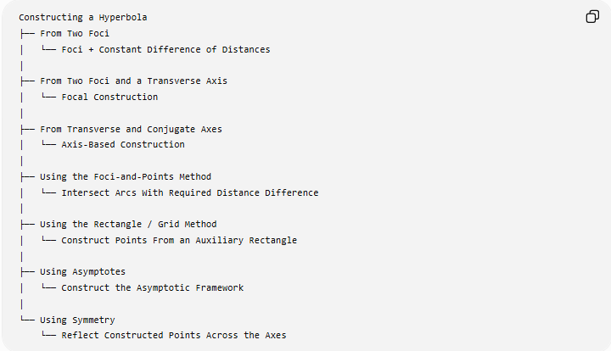
Constructing a Hyperbola
├── From Two Foci
│ └── Foci + Constant Difference of Distances
│
├── From Two Foci and a Transverse Axis
│ └── Focal Construction
│
├── From Transverse and Conjugate Axes
│ └── Axis-Based Construction
│
├── Using the Foci-and-Points Method
│ └── Intersect Arcs With Required Distance Difference
│
├── Using the Rectangle / Grid Method
│ └── Construct Points From an Auxiliary Rectangle
│
├── Using Asymptotes
│ └── Construct the Asymptotic Framework
│
└── Using Symmetry
└── Reflect Constructed Points Across the Axes
Classification note: these are construction methods or construction situations, not different mathematical types of hyperbolas.

Basic Constructions Used
# Source: AI Source: Provided by: [Data Path: Persons Table -> ID Column: 1, Name_En Column: Motasem Essam] -> From: [ChatGPT] on [7/25/2026]
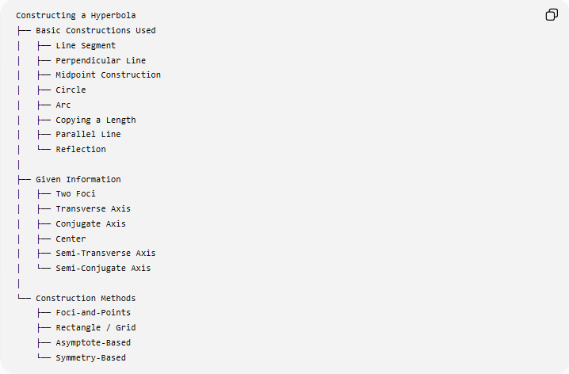
Constructing a Hyperbola
├── Basic Constructions Used
│ ├── Line Segment
│ ├── Perpendicular Line
│ ├── Midpoint Construction
│ ├── Circle
│ ├── Arc
│ ├── Copying a Length
│ ├── Parallel Line
│ └── Reflection
│
├── Given Information
│ ├── Two Foci
│ ├── Transverse Axis
│ ├── Conjugate Axis
│ ├── Center
│ ├── Semi-Transverse Axis
│ └── Semi-Conjugate Axis
│
└── Construction Methods
├── Foci-and-Points
├── Rectangle / Grid
├── Asymptote-Based
└── Symmetry-Based

Fundamental Properties
# Source: AI Source: Provided by: [Data Path: Persons Table -> ID Column: 1, Name_En Column: Motasem Essam] -> From: [ChatGPT] on [7/25/2026]
Transverse Axis
$$\boxed{2a}$$
Conjugate Axis
$$\boxed{2b}$$
Focal Distance
$$\boxed{2c}$$
Relationship
For a hyperbola:
$$\boxed{c^{2}=a^{2}+b^{2}}$$
Eccentricity
The eccentricity is:
$$\boxed{e=\frac{c}{a}}$$
For a hyperbola:
$$\boxed{e>1}$$
This distinguishes it from an ellipse:
$$0≤e<1$$
and a parabola:
$$e=1$$

Area of the Fundamental Rectangle
The auxiliary rectangle associated with the asymptotes has dimensions:
$$2a×2b$$
Therefore, its area is:
$$\boxed{A_{\text{rectangle}}=4ab}$$
This rectangle is a construction aid and should not be confused with an area enclosed by the hyperbola.

Symmetry
A central hyperbola has:
- symmetry about the transverse axis;
- symmetry about the conjugate axis;
- point symmetry about the center.
Therefore, it has:
$$\boxed{2\text{ reflection axes}}$$
and rotational symmetry of order 2:
$$\boxed{{180}^{∘}}$$

Hyperbola vs Ellipse
# Source: AI Source: Provided by: [Data Path: Persons Table -> ID Column: 1, Name_En Column: Motasem Essam] -> From: [ChatGPT] on [7/25/2026]
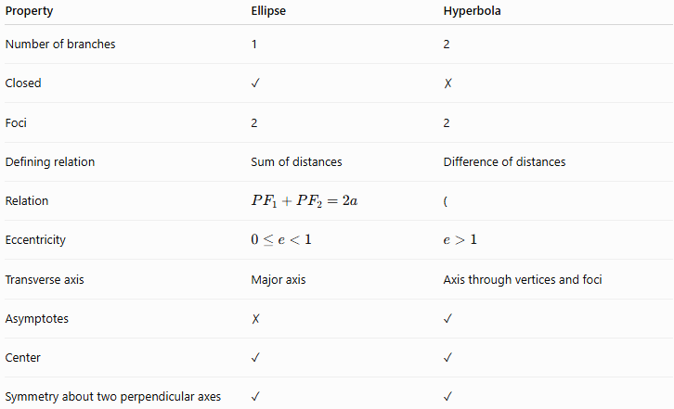
Property | Ellipse | Hyperbola
Number of branches | 1 | 2
Closed | ✓ | ✗
Foci | 2 | 2
Defining relation | Sum of distances | Difference of distances
Relation | $$PF_{1}+PF_{2}=2a$$ | (
Eccentricity | $$0≤e<1$$ | $$e>1$$
Transverse axis | Major axis | Axis through vertices and foci
Asymptotes | ✗ | ✓
Center | ✓ | ✓
Symmetry about two perpendicular axes | ✓ | ✓

Hyperbola vs Parabola
# Source: AI Source: Provided by: [Data Path: Persons Table -> ID Column: 1, Name_En Column: Motasem Essam] -> From: [ChatGPT] on [7/25/2026]
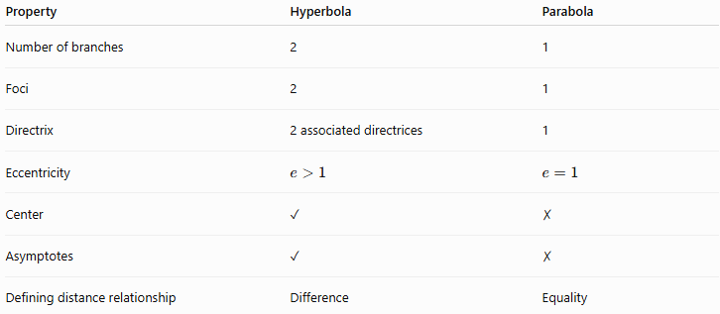
Property | Hyperbola | Parabola
Number of branches | 2 | 1
Foci | 2 | 1
Directrix | 2 associated directrices | 1
Eccentricity | $$e>1$$ | $$e=1$$
Center | ✓ | ✗
Asymptotes | ✓ | ✗
Defining distance relationship | Difference | Equality

Ellipse, Parabola, and Hyperbola
# Source: AI Source: Provided by: [Data Path: Persons Table -> ID Column: 1, Name_En Column: Motasem Essam] -> From: [ChatGPT] on [7/25/2026]
The three principal non-degenerate conic sections can be classified by eccentricity:
$$\boxed{\begin{aligned}0≤e<1&→\text{Ellipse} \\ e=1&→\text{Parabola} \\ e>1&→\text{Hyperbola}\end{aligned}}$$
The focal definitions also differ:
$$\boxed{\text{Ellipse: }PF_{1}+PF_{2}=\text{constant}} \\ \boxed{\text{Parabola: distance to focus = distance to directrix}} \\ \boxed{\text{Hyperbola: }∣PF_{1}-PF_{2}∣=\text{constant}}$$

Classification in Geometric Construction
# Source: AI Source: Provided by: [Data Path: Persons Table -> ID Column: 1, Name_En Column: Motasem Essam] -> From: [ChatGPT] on [7/25/2026]
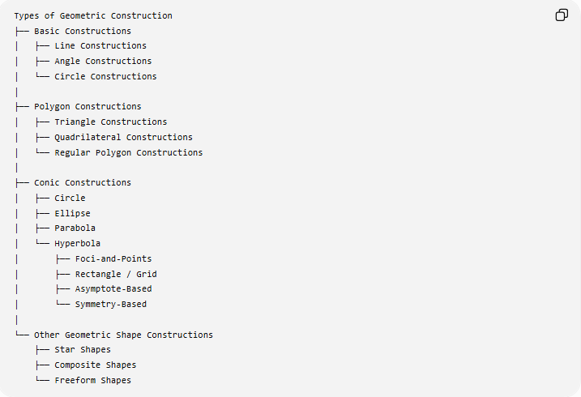
Types of Geometric Construction
├── Basic Constructions
│ ├── Line Constructions
│ ├── Angle Constructions
│ └── Circle Constructions
│
├── Polygon Constructions
│ ├── Triangle Constructions
│ ├── Quadrilateral Constructions
│ └── Regular Polygon Constructions
│
├── Conic Constructions
│ ├── Circle
│ ├── Ellipse
│ ├── Parabola
│ └── Hyperbola
│ ├── Foci-and-Points
│ ├── Rectangle / Grid
│ ├── Asymptote-Based
│ └── Symmetry-Based
│
└── Other Geometric Shape Constructions
├── Star Shapes
├── Composite Shapes
└── Freeform Shapes

Key Points
# Source: AI Source: Provided by: [Data Path: Persons Table -> ID Column: 1, Name_En Column: Motasem Essam] -> From: [ChatGPT] on [7/25/2026]
- A hyperbola is an open conic with two separate branches.
- It is defined by a constant difference between distances to two foci:
$$\boxed{∣PF_{1}-PF_{2}∣=2a}$$
- Its standard horizontal equation is:
$$\boxed{\frac{x^{2}}{a^{2}}-\frac{y^{2}}{b^{2}}=1}$$
- Its focal relationship is:
$$\boxed{c^{2}=a^{2}+b^{2}}$$
- Its eccentricity satisfies:
$$\boxed{e>1}$$
- It has two vertices separated by the transverse axis:
$$\boxed{2a}$$
- It has a conjugate axis of length:
$$\boxed{2b}$$
- Its asymptotes are:
$$\boxed{y=±\frac{b}{a}x}$$
for the standard horizontal hyperbola.
- It has two reflection axes and ${180}^{∘}$rotational symmetry.
- It can be constructed using foci-and-points, rectangle/grid, asymptote, and symmetry methods.

Conclusion
# Source: AI Source: Provided by: [Data Path: Persons Table -> ID Column: 1, Name_En Column: Motasem Essam] -> From: [ChatGPT] on [7/25/2026]
A hyperbola is a two-branched conic section defined by the constant difference between the distances from any point on the curve to two fixed foci. Its construction is fundamentally different from that of an ellipse because the ellipse uses a constant sum, whereas the hyperbola uses a constant difference:
$$\boxed{∣PF_{1}-PF_{2}∣=2a}$$
The hyperbola can be constructed from its foci, axes, asymptotes, or an auxiliary rectangle, with symmetry allowing one constructed branch to generate the remaining parts.

